DESIGN
1. System Design
System design describes the architecture, data flow, and interactions of the AKIRA (Accessible Knowledge & Information Retrieval Assistant) application. The system is designed to retrieve encyclopedic information, simplify it into study material, and provide accessible reading and learning features.
1.1 System Architecture
AKIRA follows a client-server architecture. The frontend sends requests to the backend, which retrieves article content, processes it, and returns the results. The system also manages search history, bookmarks, and study-material exports.
The major components are the user interface, request-handling logic, content-processing module, database operations, and export functionality. The browser provides voice input and audio playback, while the database maintains persistent records.
Figure 4.1: System Architecture Diagram
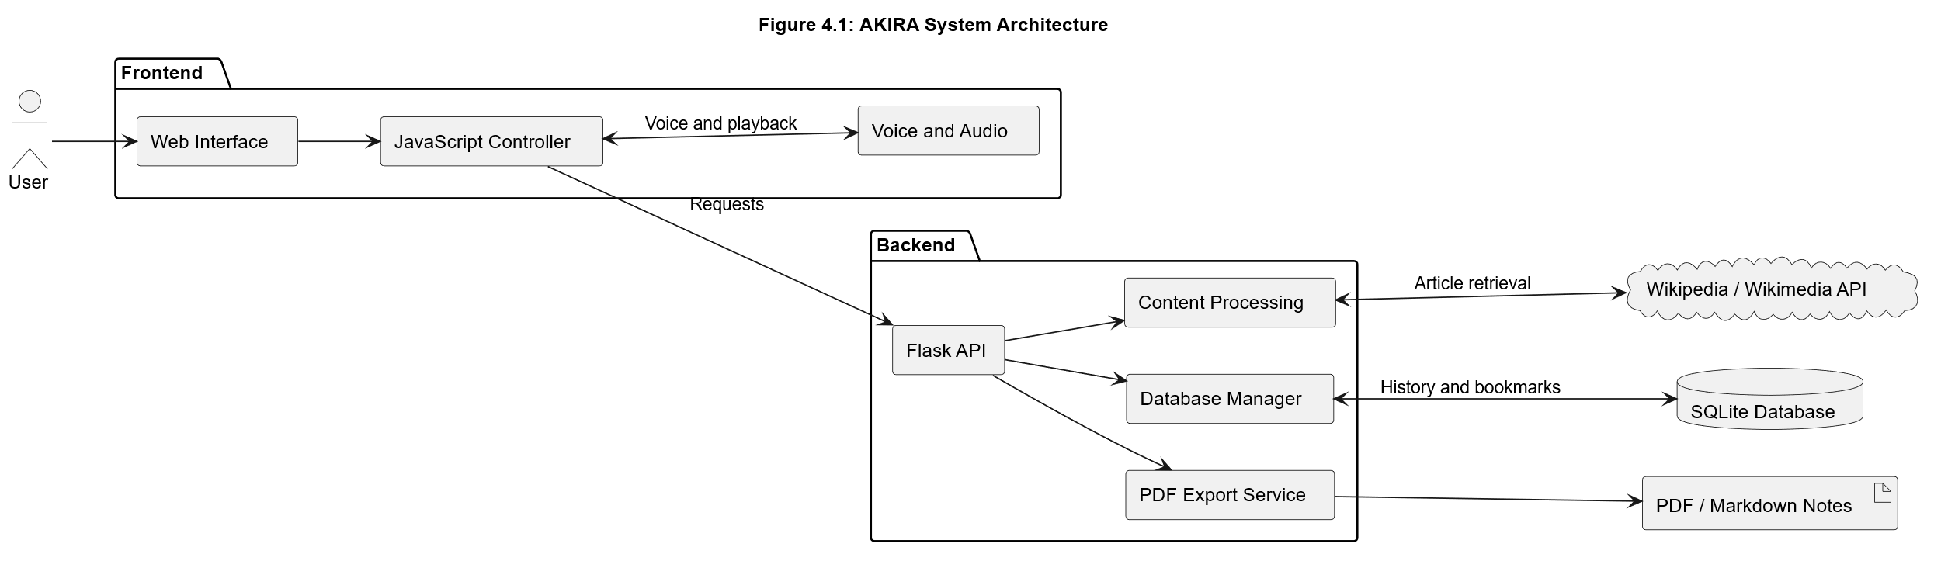
1.2 Data Flow Diagrams (DFD)
The Data Flow Diagrams illustrate how information moves through AKIRA, from a user's search request to the presentation and storage of results.
Context-Level DFD: The system is represented as a single process interacting with the user, the Wikipedia/Wikimedia API, and the database. The user receives processed information and study materials, while the system retrieves articles and manages saved data.
Figure 4.2: Context-Level DFD of AKIRA
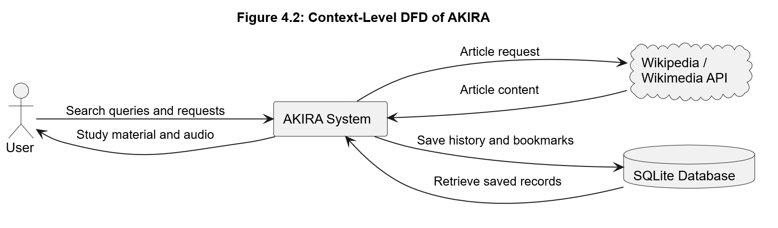
Level 1 DFD: This diagram expands AKIRA into its major processes: handling queries, retrieving articles, processing content, presenting study materials, managing saved data, and exporting notes.
Figure 4.3: Level 1 DFD of AKIRA
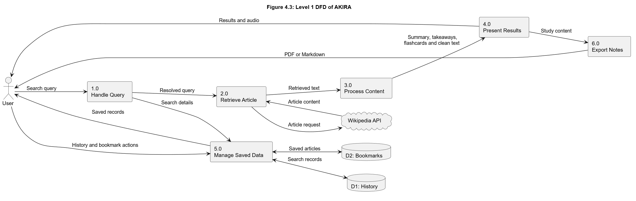
1.3 UML Use Case Diagram
The Use Case Diagram presents the main functions available to users. These include searching by text or voice, viewing summaries, studying with flashcards, listening to articles, changing accessibility settings, managing bookmarks and history, and exporting study materials.
Figure 4.4: Use Case Diagram of AKIRA
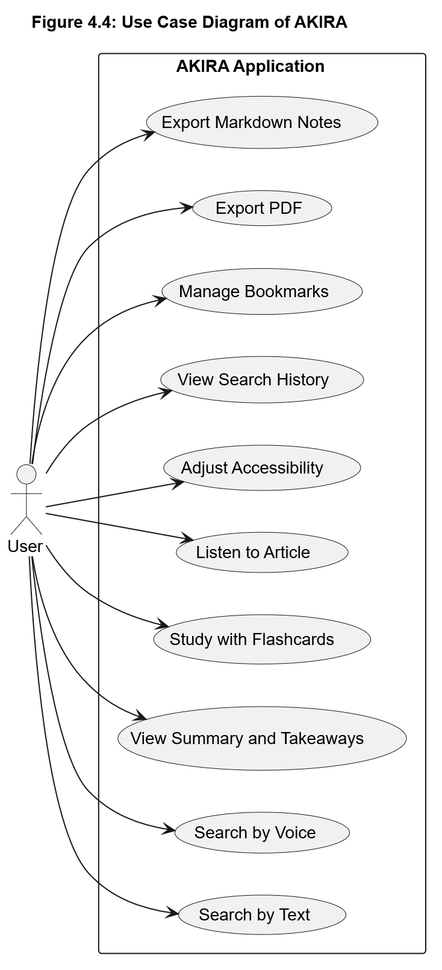
1.4 Design Rationale and Trade-Off Study
The design decisions were based on the project's functional requirements, implementation complexity, maintainability, and cost. The following qualitative comparison summarizes the main trade-offs.
Design choice | Alternative | Rationale and trade-off
Client-server architecture | Single, tightly coupled application | Separates the interface from backend processing and simplifies maintenance.
SQLite database | Server-based relational database | Reduces setup and administration for the project's storage requirements, but is less suitable for larger multi-user deployments.
External encyclopedia API | Locally maintained article collection | Provides access to a broad range of articles without maintaining a large dataset, but depends on network and API availability.
Browser-based speech | Separate speech service | Avoids a paid service dependency, but browser and device support can vary.
Modular backend | One large application module | Improves separation of responsibilities and testability, at the cost of maintaining multiple modules.

This comparison is qualitative rather than a numerical benchmark study. No measured performance scores or weighted trade-off results are available in the project documentation. The selected design prioritizes accessibility, maintainability, low setup complexity, and cost efficiency.
2. Database Design
AKIRA uses SQLite to store search history and bookmarked articles. The database is managed through a dedicated database module and contains two primary tables: history and bookmarks.
2.1 Search History Table
The history table stores the user's search queries and related information.
Field | Data type | Description
id | INTEGER | Primary key; auto-incremented
query | TEXT | Required search query
mode | TEXT | Search mode; defaults to standard
created_at | DATETIME | Record creation timestamp
An index on created_at in descending order supports retrieval of recent searches.
2.2 Bookmarks Table
The bookmarks table stores article information saved by users for future reference.
Field | Data type | Description
id | INTEGER | Primary key; auto-incremented
title | TEXT | Required, unique article title
summary | TEXT | Article summary
url | TEXT | Article URL
takeaways | TEXT | JSON-encoded array of key takeaways
created_at | DATETIME | Record creation timestamp
The unique constraint on title prevents duplicate bookmark titles. An index on title supports title-based searches.
2.3 Entity Relationship Diagram (ERD)
The ER diagram represents the structure of the two database tables and their attributes. Both tables have independent primary keys. The documented schema does not define a direct foreign-key relationship between them.
Figure 4.5: Entity Relationship Diagram of AKIRA
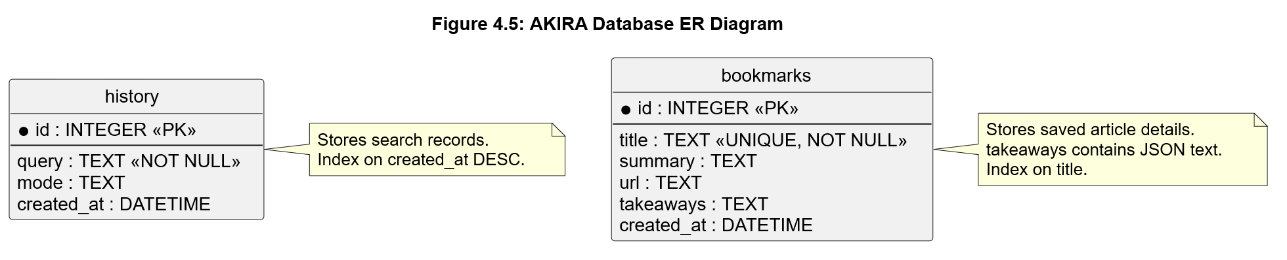

2.4 Database Design Rationale
SQLite was selected because it provides persistent relational storage without requiring a separate database server. This keeps deployment and maintenance simple for the project's scope.
Separating history and bookmarks allows search records and saved articles to be managed independently. Primary keys uniquely identify records, constraints help prevent duplicate bookmarks, and indexes support common retrieval operations. Storing takeaways as JSON-encoded text keeps the schema simple, although a separate table would be preferable if individual takeaways needed to be queried independently.
The database supports creating, retrieving, and deleting history and bookmark records, along with updating saved information where implemented. These operations provide the persistence required for AKIRA's study and reference features.
Summary
The design combines a modular application architecture with a simple database structure. The architecture and DFDs describe the system's components and data movement, the Use Case Diagram summarizes user-facing functions, and the ER diagram documents persistent storage. Together, these designs provide a clear foundation for the implementation and testing chapters.

